

SSP

v. 0.1.4

Table of Contents

Overview 4

Installation 7

Suggested configurations 7

Upgrading 7

Space requirements 7

Package configuration file 7

SSP-SIS interaction 7

Method #1 8

Method #2 9

Method #3 10

SSP side 11

Operator Mode 12

Data import 12

Interactive data editing 13

Data augmentation 13

XBT probes 13

XSV probes 14

Manual user insertions 14

Applying surface sound speed 15

Profile extension using WOA/RTOFS atlases or a reference cast 15

Data storage 16

Data transmission 17

Data export 17

Additional functionalities 17

Create a WOA or RTOFS profile 17

Request profile from SIS 18

Using a reference cast 18

Refraction monitor 19

Network data reception 20

Server Mode 22

Serving to multiple clients 22

List of References 23

APPENDIX A – Oceanographic atlases in use 24

World Ocean Atlas 24

Global Real-Time Ocean Forecast System 24

Synthetic cast values derived from atlases 24

WOA09-based profiles 25

WOA13-based profiles 25

RTOFS-based profiles 25

APPENDIX B – Connection settings 27

Settings for data reception 27

Moving Vessel Profiler 27

Sippican 28

Settings for data transmission 28

Kongsberg SIS 28

Hypack 30

QINSy 33

PDS2000 38

# Overview

The SSP hydro-package has been developing with the aim to merge together functionalities present in several applications that process sound speed profiles (SSP) for underwater acoustic systems. The core functionalities come from SVP Editor, an application originally developed at the Center for Coastal and Ocean Mapping (CCOM, UNH) by Jonathan Beaudoin (Multibeam Advisory Committee) under the NSF grant 1150574, to provide pre-processing tools to help bridge the gap between sound speed profiling instrumentation and multibeam echosounder acquisition systems. In the conversion from this original implementation to the current hydro-package several improvements have been introduced to enhance code maintainability, to make it available in the Pydro environment, as well as to also to support Python 3 (from the original Python 2 only implementation) and to store the collected data for further processing and analysis.

Currently, the hydro-package can operate in two mutually exclusive operation modes:

1. *Operator Mode*
2. *Server Mode*

The *Operator Mode* represents the primary mode, and it is used to convert data from different source formats, to graphically edit them, and to export/send the resulting profiles for use by underwater acoustic systems. Optional steps are the augmentation with measurements from a reference cast (to either improve salinity modeling or extrapolate the cast to the required depth), either manually specifiying a loaded profile as reference cast, or deriving the reference from oceanographic models (currently, WOA09 and RTOFS) as described in APPENDIX A – Oceanographic atlases in use. The *Server Mode* was developed to deliver WOA/RTOFS-derived synthetic SSPs to one or more network clients in a continuous manner, enabling opportunistic mapping while underway. Given the uncertainty of such an approach, this mode is expected to only be used in transit, capturing the current position and using it as input to lookup into the selected oceanographic model.

Currently implemented features include:

1. Import of several commonly used sensor/file formats:
   1. Castaway (.csv)
   2. Digibar Pro (.txt), and S (.csv)
   3. Idronaut (.txt)
   4. Seabird (.cnv)
   5. XBT, XSV, and XCTD Sippican (.EDF)
   6. XBT Turo (.nc)
   7. University of New Brunswick (.unb)
   8. Valeport Midas (.000), MiniSVP (.txt), and Monitor (.000),
2. Network reception of data from:
   1. Sippican systems
   2. Moving Vessel Profiler (MVP) systems
3. Data visualization and interactive graphical inspection (e.g., outlier removal, point additions) of sound speed, temperature and salinity profiles
4. Use of the World Ocean Atlas of 2009 (WOA09) and/or Real‐Time Ocean Forecast System (RTOFS) for tasks such as:
   1. Salinity augmentation for Sippican XBT probes
   2. Temperature/salinity augmentation for Sippican XSV probes and SVP sensors
   3. Vertical extrapolation of measured profiles
   4. Creation of synthetic sound speed profiles from the model of choice
5. Augmentation of sound speed profile surface layer with measured surface sound speed (from Kongsberg SIS only)
6. Designation of a reference profile, for example from a deep CTD, for use in tasks such as:
   1. Salinity augmentation for Sippican XBT probes
   2. Temperature/salinity augmentation for Sippican XSV probes and SVP sensors
   3. Vertical extrapolation of measured profiles
7. Export of several file formats:
   1. Caris (.svp) (V2, multiple casts supported)
   2. Comma separated values (.csv)
   3. Elac Hydrostar (.sva)
   4. Hypack (.vel)
   5. IXBLUE (.txt)
   6. Kongsberg Maritime (.asvp)
   7. Sonardyne (.pro)
   8. University of New Brunswick (.unb)
8. Network transmission of processed casts to data acquisition systems (see APPENDIX B – Connection settings)
   1. Kongsberg Maritime SIS
   2. QPS QINSy
   3. Reson PDS2000
   4. Hypack
9. Persistent storage of collected SSP data

# Installation

## Suggested configurations

Given its specific aim, this hydro-package is usually installed to run in one of two configurations:

1. *On the machine used for sound speed profile acquisition.* This represents a quite common choice since many of the operations accomplished in the software are typically done immediately after acquisition of a cast. If the machine is on the same network as the multibeam acquisition workstation, the SSP can be directly delivered via network. When this is not possible, the package can export the processed data to files that can then be manually uploaded to the multibeam workstation.
2. *On the multibeam acquisition workstation.* This configuration is particularly useful when it is anticipated that the software will run in Server Mode. In fact, it is important that multibeam watch standers are able to monitor the server and to disable it in the event that a measured profile is to be uploaded.

## Upgrading

You will need to migrate specific configuration settings from your previous installation over into the new configuration file. The migration of configuration settings is currently done manually.

## Space requirements

Approximately 2GB of additional disk space is required for the WOA09 data set optionally required (but warmly suggested) by this hydro-package. If not available, the package will attempt to download it. Alternatively, it is also possible to manually download, unpack the WOA09 data set, and modify the configuration file to point to the correct path (see Package configuration).

## Package configuration file

In the hydro-package installation folder, you can find a configuration file: *config.ini*. This text file has to be modified to reflect the chosen software deployment and environment-specific configuration settings (e.g., the SIS IP address and ports). Read the file comment (which begin with a ‘#’ character) for the available configuration options.

## SSP-SIS interaction

In order to automatically interact with Kongsberg SIS, some initial configuration are required on the SIS side to make it to broadcast a specific subset of datagrams that can then be interpreted by the SSP hydro-package (identification codes in parentheses):

1. *Position (‘P’, 80, 0x50)*: for retrieveing current date and position
2. *Sound Speed Profile (‘U’, 85, 0x55)*: checking whether a SSP transmission was successful
3. XYZ88 (‘X’, 88, 0x58): to retrieve:
   1. The surface sound speed (used in beam forming and steering) and the transducer draft (both used when augmenting SSPs with the measured surface sound speed value).
   2. The depth (to estimate the approximate water depth). This is used in the sound speed, temperature and salinity plots to help the user appreciate the minimal depth to which the profiles should be extended.

Kongbserg SIS can be configured to broadcast datagrams in different ways:

### Method #1

This method is usually used for the case where the hydro-package and SIS are installed on the same machine. However, since the *User Defined* UDP port cannot be modified, this method may not be suitable if this mechanism is already in used by another program. In such a case, the *DataDistrib.exe* program explored in Method #3 may be attempted. The configuration for this method is actually quite simple:

1. Stop pinging
2. Access the *Installation Parameters* dialog (Figure 1) from the *View* menu by choosing *Tear off* and then *Installation Parameters*

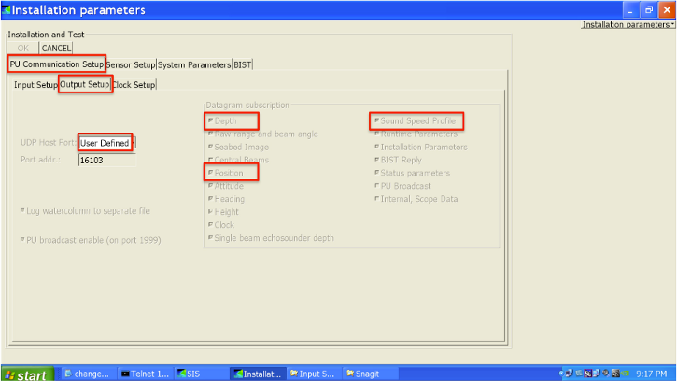

Figure 1 - SIS Installation parameters dialog, with key settings in red for method #1.

1. Select the *PU Communication Setup* tab and then choose the *Output Setup* sub-tab.
2. Choose *User Defined* from the *UDP Host Port* dropdown menu (the default output port varies with the MBES model). Take a note of this for configuring SSP Manager later.
3. Select the following datagrams: *Depth*, *Position* and *Sound Speed Profile*.
4. Click the *OK* button at the top left of the tabbed panels.
5. Restart pinging.

### Method #2

This method is more general, and it can be used for data transmission to other computers on the network (by specifying IP address and port, as well as transmission rate). *SIS needs to be restarted for the changes to take effect.* Furthermore, since the software does not seem to validate user inputs, mistakes made cannot be easily discovered and undone (unsubscribe).

1. From the *Tools* menu, choose *Custom…* and then *Datagram Distribution*.

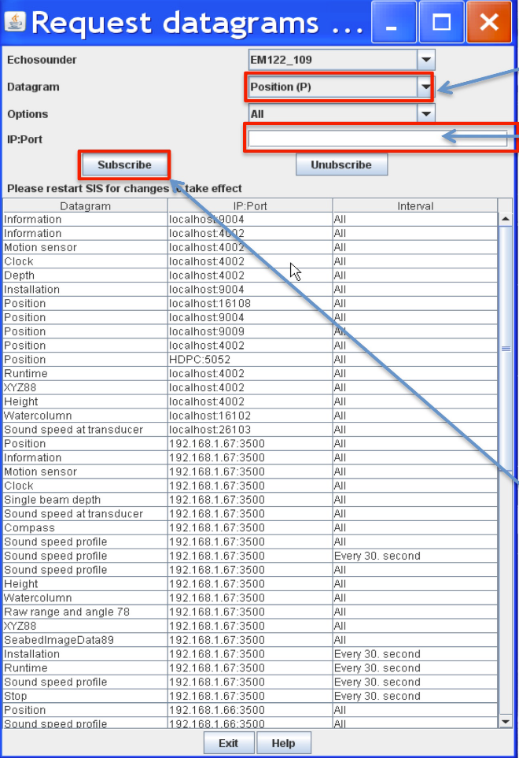

Figure 2 – Datagram Distribution dialog, with key settings in red for method #2.

1. Choose the datagram from the drop down menu, starting with *Position (P)*.
2. Type in the IP address of the remote machine where this hydro-package is installed, immediately followed by a colon (:), then the port number that the data should be delivered to on the remote machine: e.g., *192.168.1.67:16103*.
3. Click the *Subscribe* button.
4. Repeat Steps 2­4 for the *SVP (U)* and the *XYZ88 (X)* datagrams.

### Method #3

This method is required when multiple software packages need to receive data from SIS, and it represents an extension of the previous two methods. It uses a standalone program, named *DataDistrib.exe*, bundled with SIS and usually installed in *C:\Program Files\Kongsberg Maritime\SIS\bin* (together with a configuration file *DataDistrib.ini* with all the subscriptions). It is suggested to add the *DataDistrib.exe* to the *Startup* menu (so that it is automatically started). However, common backsides of this method is that the executable can be accidentally closed (stopping the data distribution to this package), or it can accidentally runs twice corrupting the configuration file (to prevent this, it could be made ‘read only’). The setup of this method is summarized as follows:

1. If the program is running already, click the icon in the taskbar to launch the graphical user interface (Figure 3). If not, navigate to *C:\Program Files\Kongsberg Maritime\SIS\bin* and double click on *DataDistrib.exe* to launch it

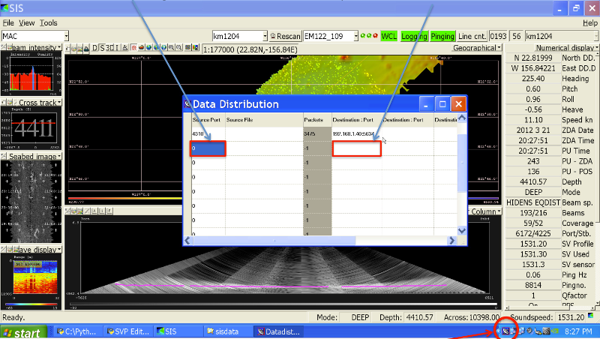

Figure 3 – The Data Distrubution application, with key settings in red for method #3.

1. Find the first empty row and enter the UDP port to which SIS has to distribute data in the left most column. Hit the *Enter* key to finalize the entry
2. In the same row, click on the fourth column and type in the IP address of the remote machine on which this package is installed, immediately followed by a colon (:), then port number that the data should be delivered to on the remote machine: e.g., *192.168.1.67:16103*. Again, hit the *Enter* key to finalize the entry. If SIS is pinging and distributing the data, you should see the packet count increase steadily in the third column.

### SSP side

The parameters, present in *config.ini*, that must be modified to match the SIS configuration are reported as *client_list* and *km_listen_port*.

As *client_list* you need to specify:

1. a name for the client (for ease of recognition)
2. the client IP address to which the data should be sent by SSP Manager (if the package is installed on the same machine as SIS, this should be 127.0.0.1)
3. the port to which the client is listening for SSP (SIS always listens port 4001 for SSP input)

The resulting row should look similar to: *client_list="Langseth SIS":192.168.3.101:4001:SIS*

The *km_listen_port* provides the port to which SIS has been configured to broadcast datagrams. This should match the port address selected in the previous methods. For instance, *km_listen_port=16103*.

If both SIS and SSP sides have been properly configured, SSP Manager will show (in the right side of the lower window statusbar) the date, geographic position, surface sound speed and average depth.

***Note:*** *the surface sound speed and depth will only update if the echosounder is pinging (since the surface sound speed information can only be extracted when the SSP package receives the depth datagram).*

# Operator Mode

## Data import

From the *File* menu, select *Import cast* and choose the desired import file type from the submenu. This will launch a file selection dialog (with the expected file extension set as a filter, e.g. *.edf* for Sippican files). A number of sample data files are distributed with this package. After the selection of the desired file, the window shows panels with the sound speed, temperature and salinity profiles drawn in solid blue (left to right, respectively, in Figure 4).

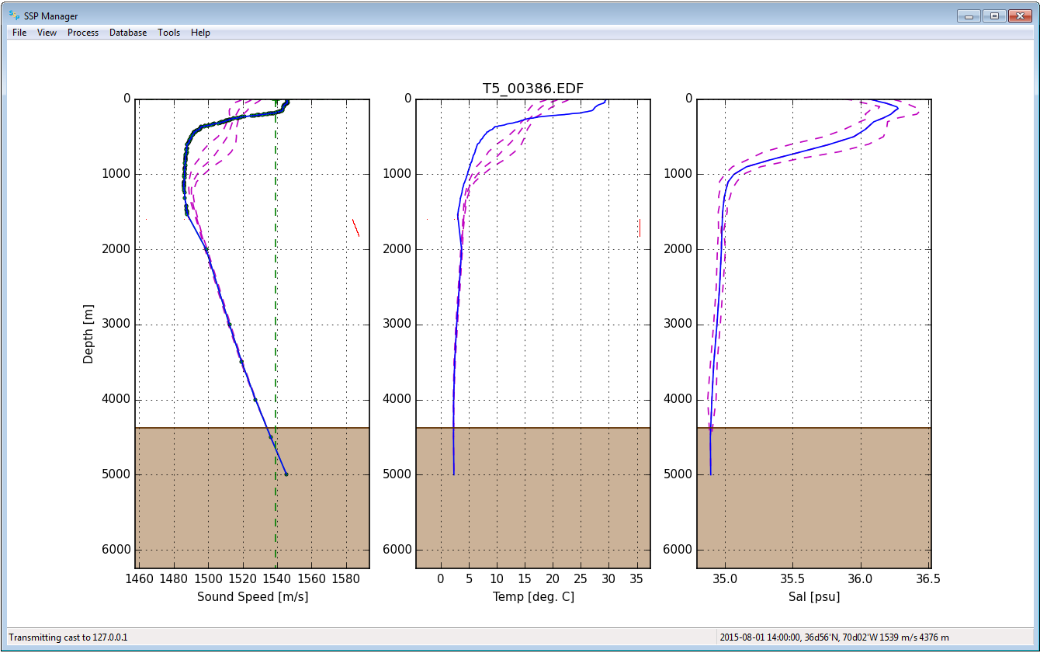

Figure 4 – SSP Manager showing the three main plots: sound speed, temperature, and salinity.

During the import stage, the geographic position and date in the input file are used to query WOA or RTOFS atlases (if available) to obtain mean sound speed, temperature and salinity profiles (to provide a context during data editing), which are drawn in dashed magenta. Thus, it is important that the cast positional metadata are correct for this lookup operation. Furthemore, the position is also required by some formats to compute the pressure to depth conversion (since this has a latitudinal dependence). Since some file formats do not support recording of geographic position (e.g., Valeport .000) the user must enter these manually during import (if the SIS position datagram is not available).

## Interactive data editing

The mouse interactive mode is set using the *Process/Visual Inspection* sub-menu (or by directly right-clicking on the plots once a cast is loaded). Currently available inspection modes are:

* Zooming: to zoom in to a selected area
* *Flagging data*: mark spurious measurements for removal from any plot panel through a left-click drag motion over the bad data points. The flagged points will be drawn in red.
* *Unflagging data*: reclaiming previously flagged data, using the same left-click and drag motion as *Flagging data*.
* *Adding points*: manually adding points to the profiles can be useful to create a more realistic cast extension. This is particularly useful when the measured temperature and/or salinity values deviate from WOA/RTOFS or the reference profile near the bottom of the profile.

Zooming back out to the full view is accomplished by choosing *Reset view* from the *View* menu (or by directly right-clicking on the plot and selecting *Reset view*). The *Hide flagged* option in the *View* menu will toggle the display of flagged points.

## Data augmentation

SSP data can be augmented with WOA/RTOFS/reference salinity and/or temperature. If a reference cast has been set, then the reference cast will be used to augment salinity and/or temperature profiles instead of the WOA/RTOFS profiles.

### XBT probes

XBT probes measure the temperature of water as they drop to the seafloor. Since the speed of sound in water is strongly affected by water temperature, this measurement can be used to estimate the sound speed profile. Since salinity can also influence the speed of sound in water, the accuracy of the sound speed estimate can be improved through better approximation of the water’s salinity. This approximation can be as simple as assuming that the salinity is constant over all depths or it could be as sophisticated as using an independent salinity depth profile from an alternate sensor such as a CTD or perhaps from an oceanographic model.

The package follows this second approach. The salinity profile is specified by selecting *XBT load salinity* from the *Process* menu (the option is only active when an XBT cast is loaded). With this command, the dashed magenta WOA or RTOFS salinity profile is used to augment the XBT temperature measurement.

Since the vertical resolution of the WOA09/RTOFS grids is coarse compared to the typical sampling interval of the measured data, the salinity estimates are linearly interpolated to the depths associated with each of the temperature observations in the measured XBT profile.

The salinity plot (right‐most of the three panels) will update with a salinity profile and sound speed plot (the left‐most panel) are updated with sound speed (recalculated using the new salinity estimates). Sound speed values are calculated using the UNESCO equation (Fofonoff and Millard, 1983).

### XSV probes

In the case of an XSV file, the user can decide to augment the measured sound speed with WOA/RTOFS temperature and salinity through the *XSV load temperature/salinity* option under the *Process* menu (the option is only active when an XSV cast is loaded).

In this mode, the sound speed is NOT recalculated, the temperature and salinity are meant merely for SIS to compute transmission loss corrections for improved backscatter normalization. Thus, the package disallows application of WOA/RTOFS salinity to XSV profiles.

### Manual user insertions

There are two methods to add points, after having selected the *Insert* mode in the *Visual inspection* sub-menu:

1. *Adding sound speed points in the sound speed plot*. This method adds points to the sound speed profile only and it holds the last observed temperature and salinity constant (i.e., it makes no attempt to update the temperature/salinity profiles for the chosen sound speed). Thus, this method is well suited for output formats or transmission protocols in which the temperature/salinity values are not used.
2. *Adding salinity and temperature points*. This method adds salinity and temperature points in their respective plots and then calculates the resulting sound speed based on the temperature/salinity plots. A first click in the salinity plot adds a salinity point. Then, a second click is required in the temperature profile (the depth of the first point in the salinity plot will be adjusted to match the depth of the second click). Finally, a third click in the sound speed plot computes the new sound speed point based on the previously selected depth/temperature/salinity values (the depth from the last click in the sound speed plot is NOT used, i.e., you can click anywhere in the sound speed plot).

Multipoint extensions are achieved through repeating the above sequence. If a deep extension that exceeds the view limits is required, repeatedly clicking near the bottom of the plots will automatically adjust the view bounds.

### Applying surface sound speed

If configured to receive data from SIS, the surface sound speed and transducer draft from the depth datagram broadcast can be used to create a surface layer of thickness equal to the transducer draft and of sound speed equal to the value used in beam forming (this is based on the assuption that the value comes from the surface sound speed probe). This operation can be achieved by selecting *Get Surface Sound Speed* from the *Process* menu.

If neither the surface sound speed or transducer draft values are available from a SIS data broadcast, the software will prompt the user to input values for both.

The intent of this feature is to keep the sound speed profile and sound speed sensor values similar such that the numerical display monitors in SIS do not warn against sound speed discrepancies between the two measurements. It should be noted that this is done internally in SIS during their ray tracing operations, regardless of this external processing stage: *“transducer depth sound speed is used as the initial entry in the sound speed profile used in the ray tracing calculations”* (Kongsberg, 2012).

Using this package method, keeps the system from warning against discrepancies based on

* The uncertainty in XBT temperature measurements (± 0.1°C, roughly equivalent to ± 0.4 m/s)
* Inadequate choice of salinity in the Sippican acquisition system
* Deviations of true salinity from the mean surface salinity in the WOA/RTOFS.

### Profile extension using WOA/RTOFS atlases or a reference cast

Profile extension can be applied by selecting *Extend cast* from the *Process* menu. This operation will extend the observed cast in depth as much as possible using the WOA/RTOFS profile. After that, the three plot panels will be updated. If necessary, users should edit any discontinuities between the cast in depth and the extension in the vicinity of the maximum observation depth.

The extension will only go as deep as 5,500 m as this is the deepest depth layer that the WOA/RTOFS atlases support (more details on such an operation are provided in APPENDIX A – Oceanographic atlases in use). However, when files are transmitted to SIS or exported in .asvp format, the software extends the profile to 12,000 m depth to meet SIS input criteria (thus, there is no need for the user do this manually).

Similar to data augmentation for XBT probes and for XSV probes, when a reference cast is set, this will be used to extend the cast instead of WOA/RTOFS atlases data.

## Data storage

The package provides also functionalities to permantently storage, delete and retrieve the SSP data. In particular, each SSP may contain three types of stored data: the raw data (that makes possible to redo the processing from scratch), the processed samples (with flags to identify the various different source of data), and an optional SIS profile (that represents the result of the thinning process required by Kongsberg SIS).

Additional functions to export in several formats (CSV, kml, shapefile) and to plot the metadata and the spatial information for the stored SSP data set.

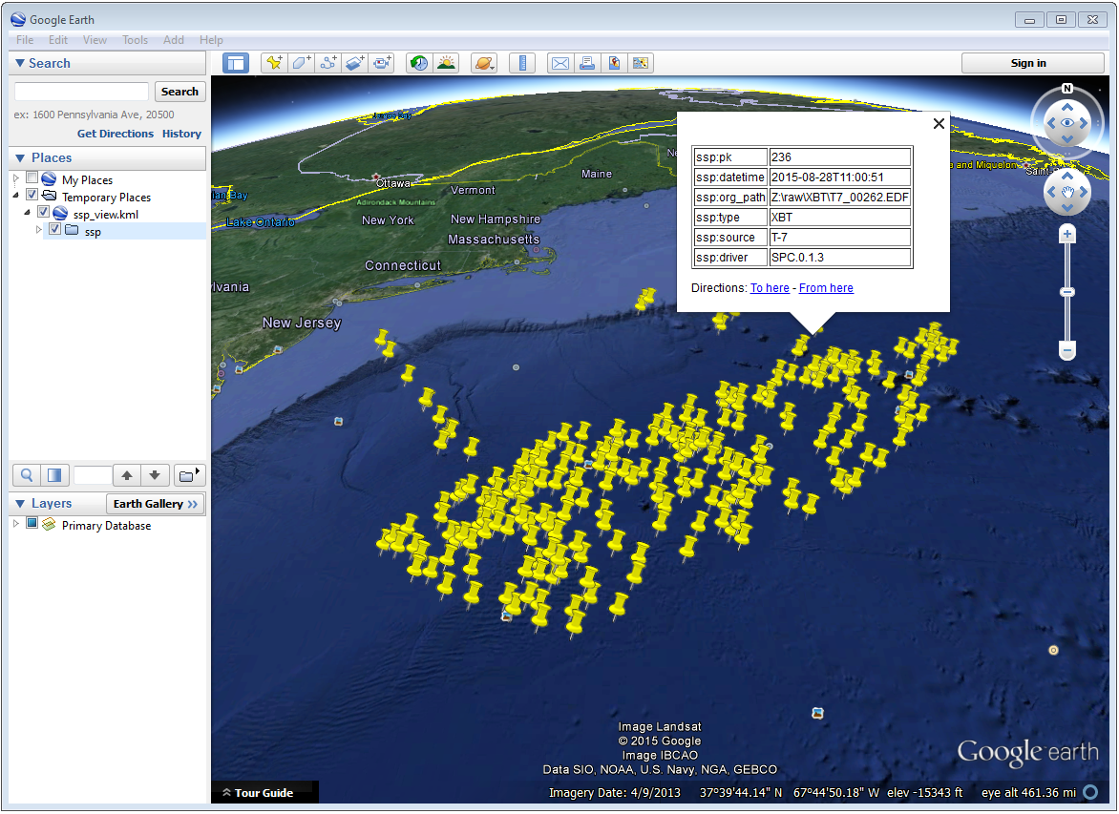

Figure 5 – Loading result of the exported metadata (kml format) in Google Earth.

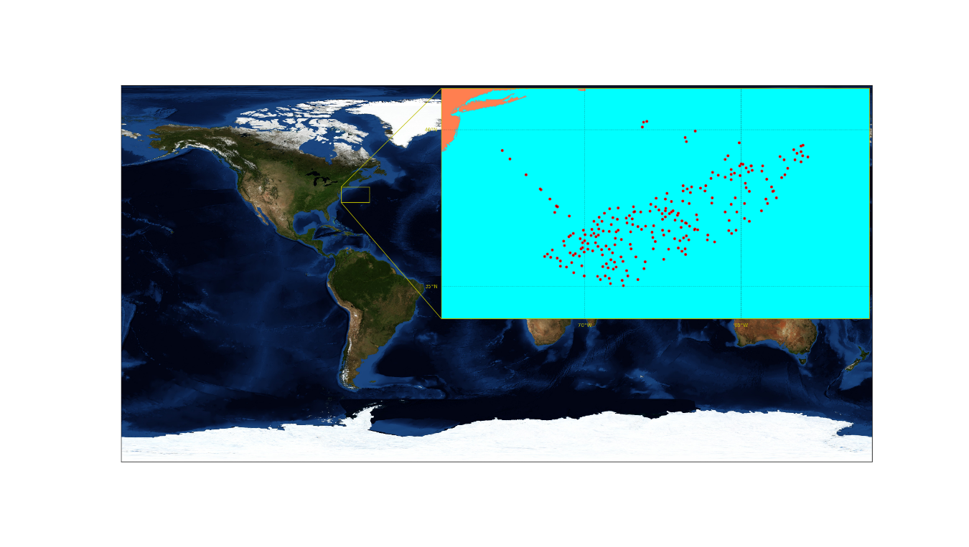

Figure 6 - Example of a map created from a stored SSP data set.

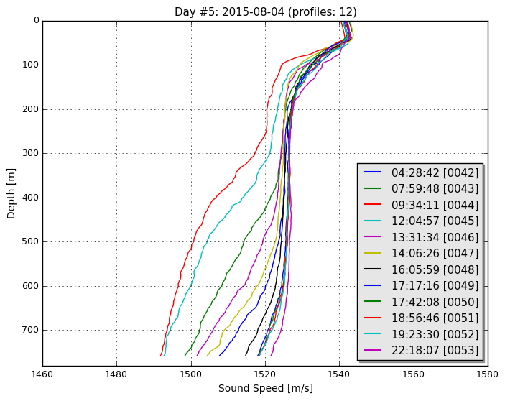

Figure 7 - Example of a daily plot that can be created from a stored SSP data set.

## Data transmission

Data transmission is triggered by selecting *Send SSP* from the *Process* menu. The recipients of such a transmission are configured in the configuration file (see Package configuration). Given that the profile accepted by SIS often requires the application of a thinning algorithm, a method *Preview thinning* is provided to inspect the result of such an algorithm before the actual transmission.

## Data export

Any file that is loaded into the package can be exported by accessing the *Export SSP* options under the *File* menu. Several formats are currently supported, so the user must select the format of interest and then choose *Export selected formats* to actually perform the export.

If configured (with ‘*export_prompt_filename*’ configuration option), the export function will prompt the user for an output prefix prior to export. If no file prompt is desired, the files will be written with the same file prefix. Furthermore, at the end of the export, the folder with the created files is opened.

## Additional functionalities

### Create a WOA or RTOFS profile

It is possible to upload a single WOA or RTOFS profile to SIS. This can be done by first select *WOA09 atlas* or *RTOFS atlas* under the *File/Query from* sub-menu. This will trigger a series of question dialogs that will determine use of the SIS date/position input for the query position or an user provided input. After that, a surface sound speed can be applied, and finally the resulting cast can be sent as described in Data transmission.

The new cast will be given the filename *YYYYMMDD_HHMMSS_WOA* or *YYYYMMDD_HHMMSS_RTOFS* with the date/time in the filename based on the query time of the cast.

### Request profile from SIS

This functionality is used to retrieve the cast currently being used by SIS and use it to create a new profile, by selecting *Kongsberg SIS* under the *File/Query from* sub-menu.

This is only possible if the package is receiving data transmissions from SIS. If it is not, the package will request a cast and will wait 60 seconds until it times out on the request. During this wait period, the package will be unresponsive to further user interaction.

If a profile is received, it will be given the name *YYYYMMDD_HHMMSS_SIS* with the date/time in the filename based on the cast time recorded by SIS.

There are a number of shortcomings regarding the Kongsberg datagram format for sound speed profiles:

* It does not preserve the latitude/longitude of the observed cast. You will be prompted to enter the position of the cast when you request the cast from SIS. It is up to you to determine the position as accurately as you require it to be, perhaps by consulting CTD/XBT logs.
* The observation time associated with the cast is known to be incorrect in the SIS sound speed profile datagram format so it is not necessarily straightforward to use the observation time to look up the navigation.
* Temperature and salinity are not included in the datagram, even if they are provided to SIS when the associated cast was originally uploaded (they are preserved internally in SIS, however).

These shortcomings are overcome through the use of the “W” datagram in SIS, however, it is not currently possible to dynamically request this datagram from SIS (though it is possible to have SIS broadcast it as discussed in the section Method #2).

### Using a reference cast

There are several scenarios where a CTD profile can be used as a reference cast by this package:

* To support XBT measurements by providing a salinity profile measurement in place of using an assumed constant salinity
* To augment SVP/XSV casts with temperature and salinity profiles to improve seafloor backscatter attenuation corrections
* Since CTD cast typically sample much deeper than most XBT probes, to provide an improved vertical extrapolation to the XBT cast.

To establish a reference cast, the desired cast is imported using the same mechanism described in Data import. After that the profile is verified, edited and perhaps extended further in depth using an oceanographic database, it is set as the reference profile by selecting *Set reference cast* under the *Tools* menu.

Once a profile is set as the reference cast, the reference profile is drawn in yellow. This cast is retained in memory as the currently loaded cast to allow for additional operations, such as exporting or transmission to a sounder. The reference profile can be cleared from memory at any time via the *Clear reference cast* option under the *Tools* menu. Further extensions and augmentations will then use WOA/RTOFS.

The reference cast can be re­imported into memory by choosing *Edit reference cast* from the *Tools* menu. This will load a copy of the reference cast into memory for further manipulation. If desired, the edited version can then be set as the new reference cast and will replace the previous version.

Prior to setting a cast as the reference cast, it is advisable to export it such that future sessions do not need to repeat any reference cast processing. To do this, choose *Export* from the *File* menu, and select the .UNB format (since it is a format that can be both exported and imported).

### Refraction monitor

An experimental feature has been set up to allow the user to establish the impact of their currently loaded sound speed profile on the refraction correction by plotting swath data with the new sound speed profile applied prior to sending the profile to the multibeam echosounder. This provides a preview of the effect of the new sound speed profile allowing appropriate action if the results are not as expected without introducing artifacts into the multibeam data stream.

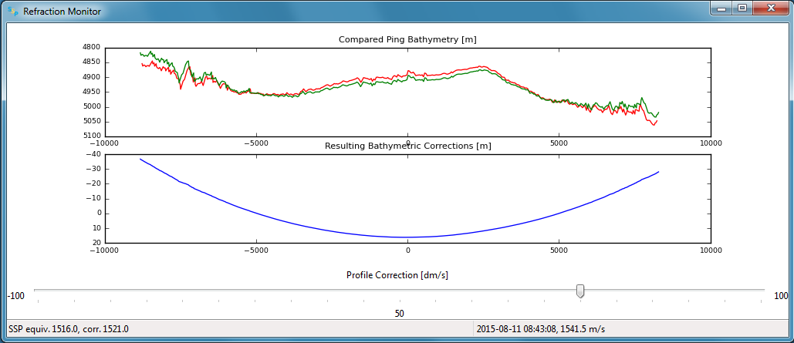

Figure 8 – Refraction monitor showing the effects of new sound speed profile before its application, as well as the application of a bias using the Profile Correction slider (at the bottom)

As an example scenario, the currently loaded profile is requested from SIS and is set as the reference profile. A new WOA profile can then be generated using the reported position from SIS. The refraction monitor can thus be used to evaluate if the profile in use by SIS does a better refraction correction than the WOA profile. The refraction correction from the WOA profile can be adjusted using the slider bar in the Refraction Monitor, this adds a bias to the WOA profile (units are dm/s) and then recomputes the new potential swath profile using the adjusted WOA profile. If the user decided to send this profile to SIS and if the refraction corrector was non-zero, the package will ask the user whether or not they want to apply this corrector to the currently loaded profile prior to sending it to the echosounder.

A few other notes on the Refraction Monitor:

* If the Refraction Monitor window is closed, the slider bar corrector value is ignored during transmission of a profile.
* The Refraction Monitor window will close automatically when the package closes a profile or generates a new profile.
* If running in Server mode, the slider bar corrector value is applied during transmission without user confirmation.
* The slider bar corrector value is reset to zero after transmission of the profile both for measured profiles and server profiles.

### Network data reception

The package is configurable to listen on specified ports for UDP input of sound speed cast data. Currently supported systems are MVP and Sippican. See APPENDIX B – Connection settings for more on how to configure these systems. The port numbers associated with various data sources can be changed in the *config.ini* file.

Upon reception of a network cast, the display panels will be colored red to indicate that operator intervention is required in order to further process the data and deliver it to the multibeam acquisition system. Once the cast has been processed and delivered, the panel color-coding will return to the normal white background.

If the *Server mode* happened to have been running at the moment of reception, it will be stopped and the received cast will be displayed as described above.

# Server Mode

The Server mode is meant for transits during which perhaps one XBT per day might be thrown. For much of the world oceans, using the WOA is a reasonable substitute for *in situ* measurements (Beaudoin et al., 2011). Given that transit data are usually a lower priority, this mode supports continuous underway logging of multibeam data that are refraction corrected, using the mean temperature and salinity profiles provided by oceanographic models. This mode should not be used if SSPs are going to be collected on a regular basis.

A preliminary requirement to run the Server Mode is that position and surface sound speed are received from SIS. This can be checked by looking in the status bar.

When this mode is active, all the user’s manual functionalities becomes unavailable until the SIS Server mode is stopped. The last sent profile is displayed in the view panel and all three plot panels are colored green. The mode can be stopped by selecting *Stop* under the *Server* menu. Closing the application will also stop the server.

To guard against accidentally overwriting a profile that was uploaded by the operator after the server was started, this mode verifies with SIS that nothing has been uploaded since the last synthetic cast was delivered. If the package finds that a profile has been uploaded, either by another program or a person, it will stop serving WOA data to SIS and will notify the user.

## Serving to multiple clients

For installations with multiple clients, the server will deliver the cast sequentially to all clients. Failure on transmission to one client will not interfere with other clients.

Once a client is deemed “dead”, i.e., no reception confirmation is received, no further attempts to send to the client are made even if a “dead” client comes back to life (a restart is required).

If all clients are deemed dead, then the server stops and notifies the user.

***Note:*** *SIS will accept and rebroadcast SVP datagrams even if it is not pinging. Thus, to make a client appearing “dead” to the server, you must shutdown SIS.*

# List of References

Beaudoin, J., Smyth, S., Furlong, A., Floc’h, H., and Lurton, X., Streamlining Sound Speed Profile Pre-Processing: Case Studies and Field Trials, *in* Proceedings US Hydro Conference 2011, April 25-29, Tampa, FL, USA2011.

Fofonoff, N. P., and Millard, R. C., 1983, Algorithms for computation of fundamental properties of seawater: Rep. No. 44, Division of Marine Sciences, UNESCO, Place de Fontenoy, 75700, Paris.

Taira, K., Yanagimoto, D., and Kitagawa, S., 2005, Deep CTD Casts in the Challenger Deep, Mariana Trench: Journal of Oceanography, v. 61, no. 3, p. 447-454.

# APPENDIX A – Oceanographic atlases in use

## World Ocean Atlas

The World Ocean Atlas is a 3-dimensional grid of mean temperature and salinity for the world’s oceans that is based upon a large set of archived oceanographic measurements in the World Ocean Database. More information about the World Ocean Atlas 2009 (WOA09) can be found online at: <http://www.nodc.noaa.gov/OC5/WOA09/pr_woa09.html>

The WOA09 netCDF temperature and salinity grids used by the package can be accessed from <http://www.nodc.noaa.gov/OC5/WOA09/netcdf_data.html>

The files required are:

* *temperature_annual_1deg.nc*
* *temperature_seasonal_1deg.nc*
* *temperature_monthly_1deg.nc*
* *salinity_annual_1deg.nc*
* *salinity_seasonal_1deg.nc*
* *salinity_monthly_1deg.nc*

Basin and land/sea masks can be downloaded from: <http://www.nodc.noaa.gov/OC5/WOA09/masks09.html>

## Global Real-Time Ocean Forecast System

The Global Real-Time Ocean Forecast System (RTOFS Global) is a 1/12°, 3-D oceanographic forecast model. More information can be found online at: <http://polar.ncep.noaa.gov/global/>

Daily forecast/nowcast grids can be downloaded via the URL listed above, but the file sizes for the daily forecast are prohibitive for use at sea. Instead, the package relies on the OpenDAP portal to download only small segments of the nowcast grids for surrounding a specified query location. The downloaded subset is a 5x5 grid centered on the query location.

## Synthetic cast values derived from atlases

The cast extrapolation algorithm vertically extends temperature and salinity profiles as deep as possible using the estimates immediately local to the area of the cast in either WOA09 or RTOFS.

### WOA09-based profiles

The World Ocean Atlas 2009 (WOA09) extension algorithm uses a nearest neighbor lookup in each of the 33 depth levels in the grids within a 3x3 grid node search box centered on the cast’s geographic position.

This is roughly equivalent to a search radius of 1.5° or 90 nmi at the equator. Note that this grid node search box becomes rapidly narrower in the east-west direction with latitude. The nearest-neighbor geodetic distance is, however, correctly computed and the nearest neighbor will indeed be the geographically most proximal grid node; the only shortcoming is that the lookup will ignore potentially closer data in the east-west direction at high latitudes. Future updates to the WOA09 extraction algorithms will remedy this shortcoming. The search radius is set this large to enable the extension to at least estimate deeper temperature and salinity values in the case where the true depth at the requested location is significantly larger than the coarse depth reported in the WOA09 grid for that location (the WOA09 grid depth will generally always be smaller than the true depth).

The search algorithm will not respect topographic boundaries and may extrapolate profiles using data from a neighboring oceanographic basin. Future versions of the algorithm will address this shortcoming as well, likely with the use of the basin mask file provided with the WOA09 data set.

### WOA13-based profiles

WOA13 represents the ocean state variables of temperature and salinity with more detail and less uncertainty than WOA09 due to large increases in data holdings and better temporal and spatial coverage coupled with refined analysis and quality control techniques:

* Increased vertical resolution (3x in the upper ocean, 2x below 1500 m.)
* Increased spatial resolution (16x)
* Release of the decadal climatologies which were used to calculate the final 1955-2012 long-term climatological mean fields.

In the specific, the package uses the WOA13v2 release that was prepared to address both methodology concerns and, to a lesser extent, quality control concerns which have surfaced since the initial release of WOA13.

### RTOFS-based profiles

The RTOFS extension algorithm differs in the size of the search area (5x5), roughly equivalent to a search radius of 0.2° or 12.5 nmi at the equator. All of the shortcomings of the WOA09 lookup described above also apply to the RTOFS lookup.

The final extrapolation to a depth of 12,000 m is done using the values measured by (Taira et al., 2005) in Challenger Deep. This could be improved by searching for the nearest neighbor grid node at the deepest level observed in the basin using the basin mask file.

# APPENDIX B – Connection settings

## Settings for data reception

### Moving Vessel Profiler

The MVP controller interface can be configured to transmit data via UDP using a variety of data format and transmission protocols (Figure 9).

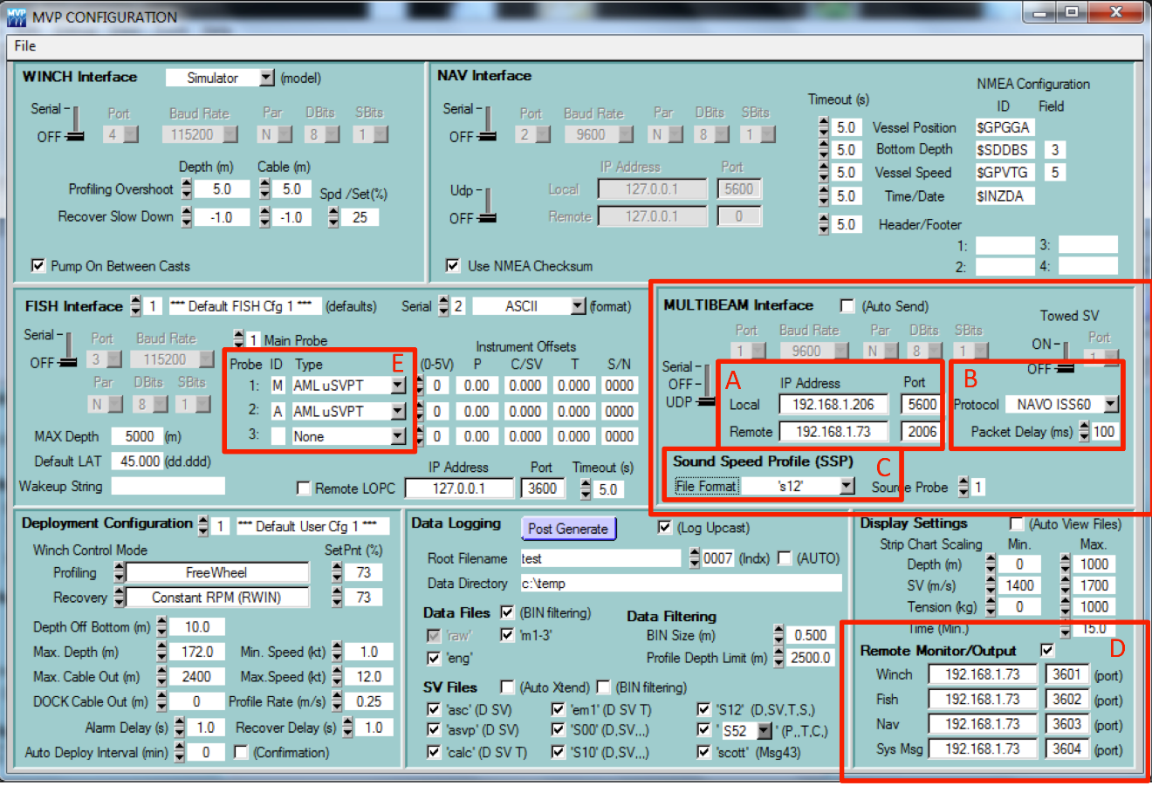

Figure 9 – MVP Controller configuration dialog. Boxes A through C are required for transmission of cast information. Box D can be configured to transmit sensor data.

The MVP computer IP address and the IP address of the machine running the SSP package can be configured in Box A. For newer versions of the MVP controller, it is recommended to choose the “NAVO_ISS60” transmission protocol as this will allow for large cast files to be transmitted in several packets without overflowing the UDP maximum packet size limitation (Box B). Older versions of the MVP controller software (up to version 2.35 to the best of our knowledge) do not support the NAVO_ISS60 protocol and the package must be configured to use the “UNDEFINED” protocol in the SSP package configuration file. The file format can be adjusted to accommodate a CTD with the “S12” format or a sound speed sensor with the “CALC” or “ASVP” formats (Box C). Note that the transmission protocol and file format must be configured in both the MVP controller interface and in the SSP package configuration file.

Boxes D and E refer to raw instrument transmission settings that are configurable for future use.

Since casts received from an MVP system do not have a filename embedded in the data stream, the SSP package will name casts received using the following convention: *YYYYMMDD_HHMMSS_MVP*. The date/time stamp embedded in the filename will be the time of the cast.

### Sippican

There does not currently exist any internal mechanism in the Sippican software to broadcast data via UDP, but this capability has been included to accommodate vessels that use UDP network broadcasts to log data from various systems. The expected data format is the Sippican native .EDF file format.

Note that a single Sippican data file can sometimes exceed the maximum buffer size for UDP packet transmissions. If software is written to transmit Sippican data files via UDP, this limitation should be kept in mind. The SSP package currently only accepts transfer of a single UDP packet thus transmission software may need to reduce the data by thinning the profile. Received profiles will use the filename embedded in the .EDF.

## Settings for data transmission

The SSP package can be configured to transmit data to a number of systems by selecting the *Send Profile* option under the *Tools* menu.

For installations with multiple clients, the SSP package will deliver the cast sequentially to all clients. Failure on transmission to one client will not interfere with other clients though it will slow down the transmission sequence through all clients for any clients who are timing out on confirmation of reception as the SSP package will wait up to 1 minute for confirmation.

Note that Server mode will only currently work with the SIS transmission protocol.

### Kongsberg SIS

SIS does not require additional configuration to receive sound speed files since it always listens on port 4001 for input sound speed data.

The following indications are useful for monitoring reception of sound speed profiles:

* The SSP profile filename will be updated in the *Runtime parameters* menu in the form: *YYYYMMDD_HHMMSS.asvp*. The date and time fields are populated based on the time stamp in the profile that was received from the SSP package. In the case of measured casts, this is the time of acquisition, as found in the input file. In the case of synthetic WOA profiles, the date/time is based on the time of transmission of the cast (using the computer clock where the SSP package is installed).
* SIS creates several files in the last location from which it loaded a sound speed profile.
* The *SVP display* window, if being viewed in SIS, will update with the new cast.
* In the event that a cast is rejected, SIS will launch a warning dialog to indicate that the cast it received was rejected.

Although SIS always will allow incoming sound speed transmissions, it has several restrictions that must be observed in order for the data to be accepted (see Kongsberg manual). As this particular transmission protocol is used by other acquisition systems, it is worth describing in detail what the SSP package does to the cast data to satisfy the input criteria for SIS.

The transmission procedure used by the SSP package will format the temperature and salinity profiles into the Kongsberg Maritime format. Since the WOA09/RTOFS grids only extend to a maximum depth of 5,500 m, the profile undergoes a final extrapolation to a depth of 12,000 m to satisfy SIS input criteria, this is done with temperature and salinity values measured in the Mariana Trench by Taira et al. (2005). Since SIS input profiles have a limit on the maximum allowable number of data points, the sound speed profile is thinned using a modified version of the Douglas-Peucker line reduction method as described by Beaudoin et al. (2011). The algorithm begins with a small tolerance and increases it linearly until the number of points in the profile falls below the maximum allowed by SIS.

By default, the cast header is formatted to instruct SIS to accept the profile for immediate application without launching the *Kongsberg SVP Editor*. This behavior can be changed through the configuration file by setting *sis_auto_apply_manual_casts=False*. In this case, SIS will accept the cast but will then launch its own editor interface and user interaction will be required on the SIS computer in order to have the cast applied to the multibeam system.

Once the cast has been prepared for transmission, it is sent to SIS via UDP transmission over the network. If SIS receives the profile and accepts it, it will rebroadcast the SVP datagram. The SSP package waits for this rebroadcast to ensure reception of the cast. The profile that was rebroadcasted from SIS is compared against that which was sent. If they match, then the transmission is considered successful. If there is a discrepancy, or if no rebroadcast profile is received, the user is notified that reception could not be confirmed. The lower left status bar notifies the user of the various stages of this verification process. In deep water, the rebroadcast event may take several seconds to occur and the software will wait up to a user-defined amount of time (e.g., 30 seconds) for reception of the rebroadcasted SVP. All other package functionalities are suspended during this wait period.

### Hypack

The SSP package can transmit data to HYPACK using HYPACK’s driver for Moving Vessel Profiler (MVP) systems (*MVP.dll*). Next figures provide a guidance on how to configure a Hypack project to receive data from SSP package.

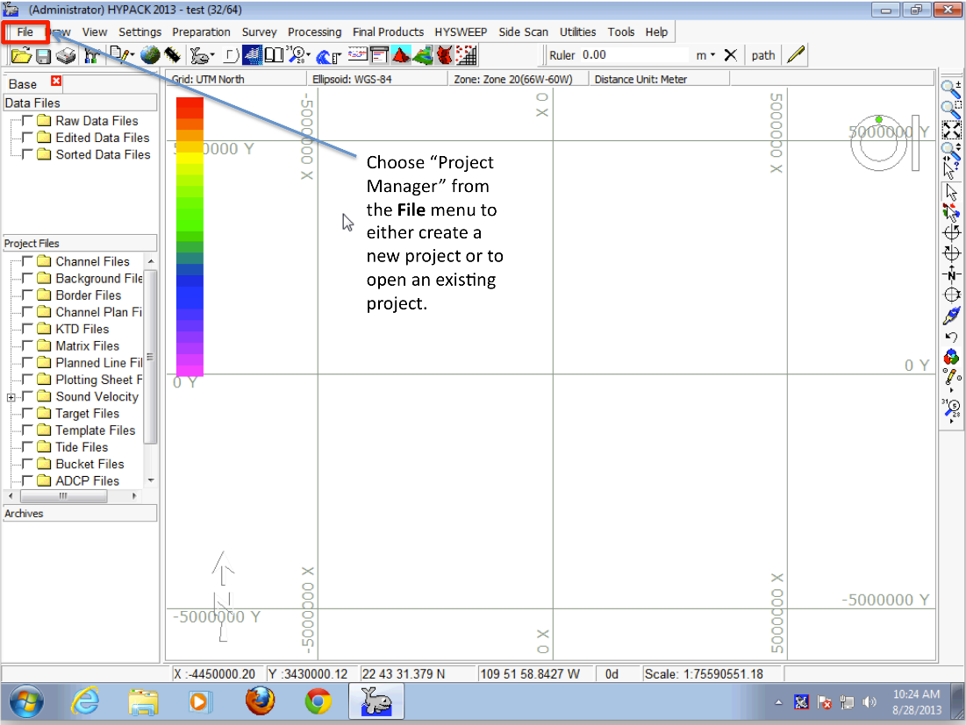

Figure 10 – Step 1: opening the project manager.

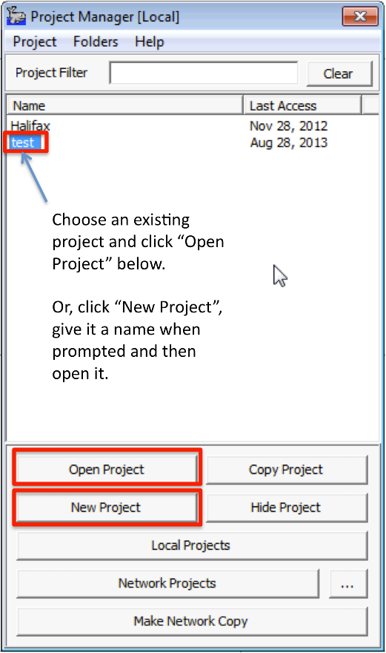

Figure 11 – Selecting or creating a Hypack project.

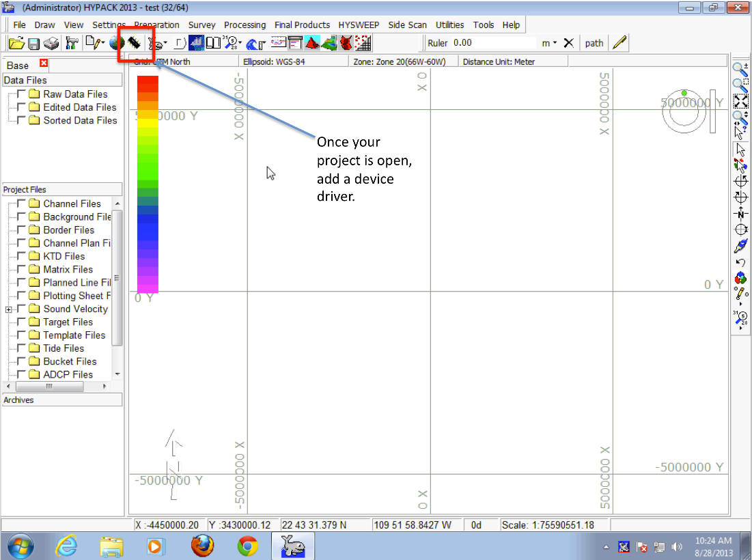

Figure 12 – Selecting the *Add device* button.

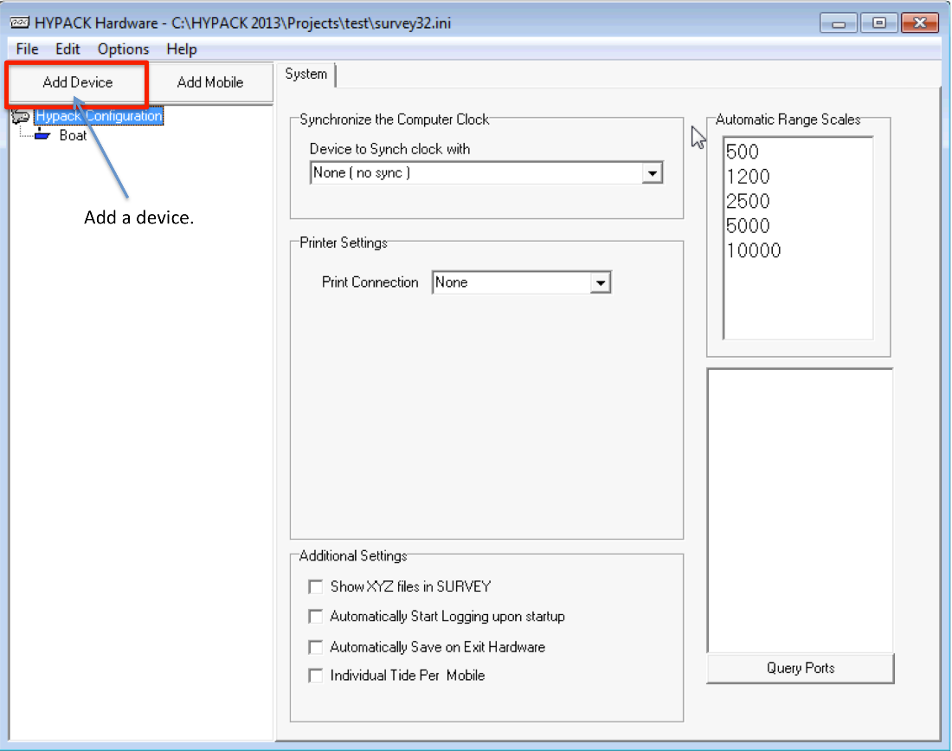

Figure 13 – Adding device drivers to a Hypack project.

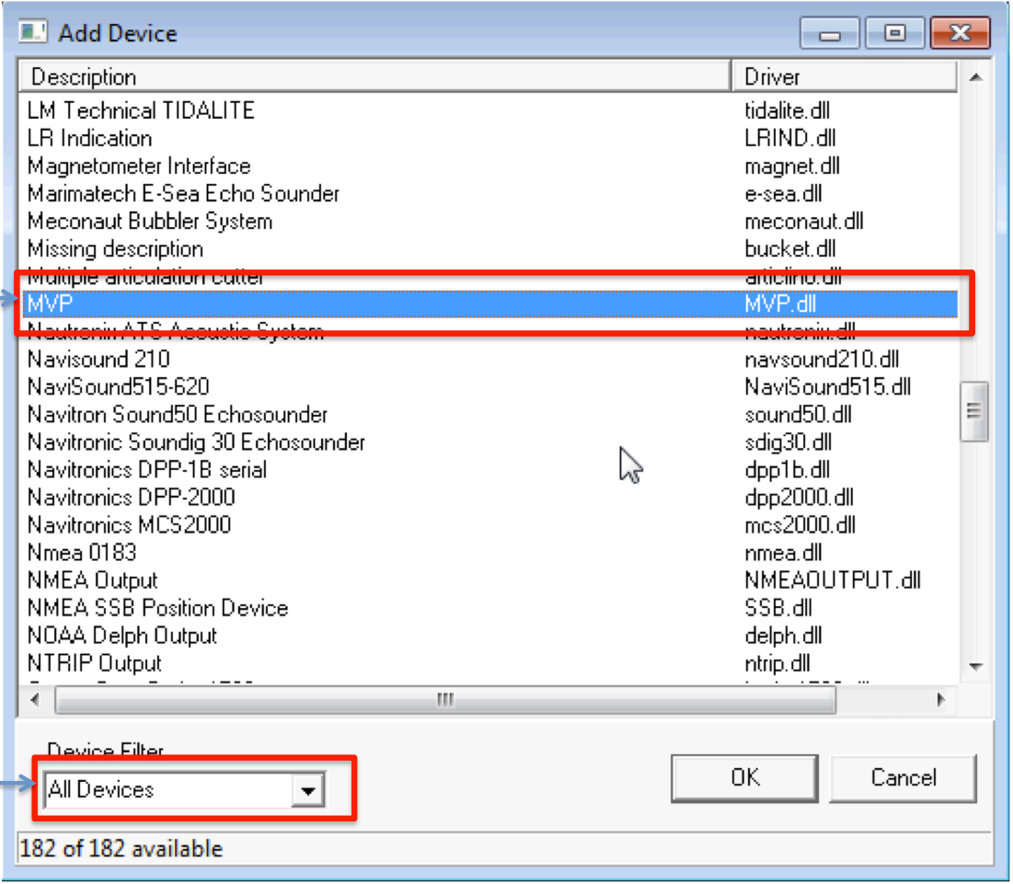

Figure 14 – Adding the MVP device driver.

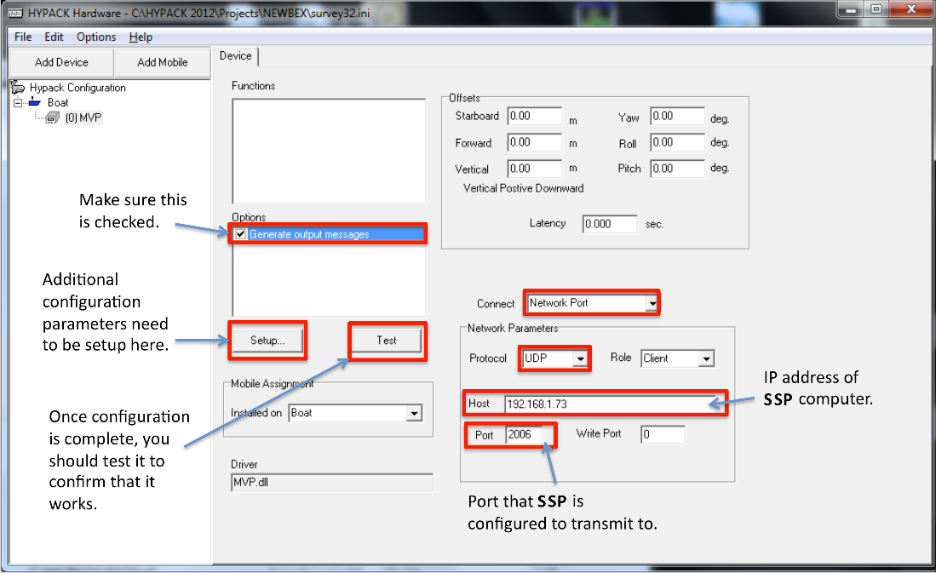

Figure 15 – Configuring the MVP driver. The network parameters of the driver are configured to use a UDP input protocol in a client role. The host IP address must match the address used by the computer running SSP and the reception port must match the port configuration chosen in the package configuration file. The “Write Port” is left as zero.

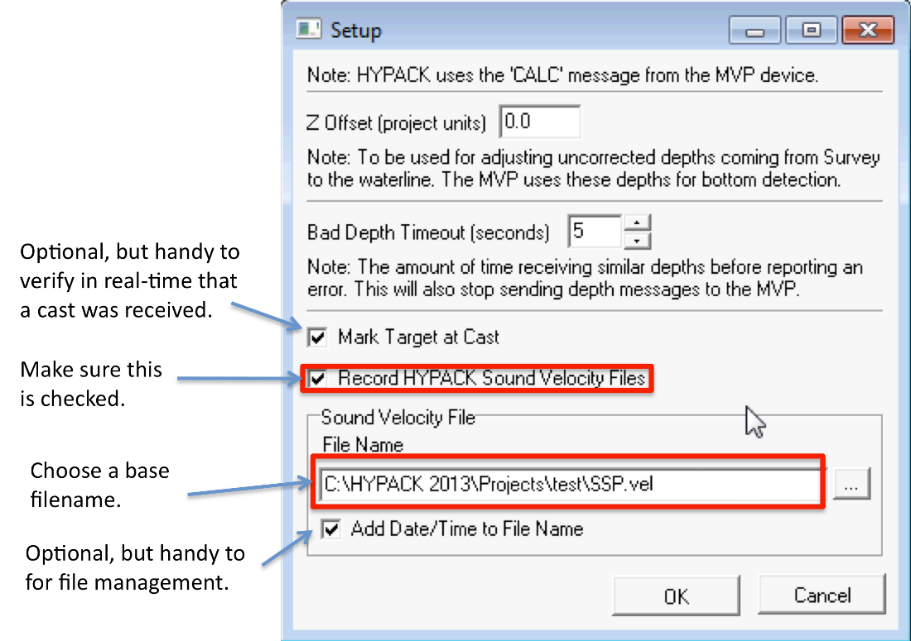

Figure 16 – Additional configuration of the MVP device driver.

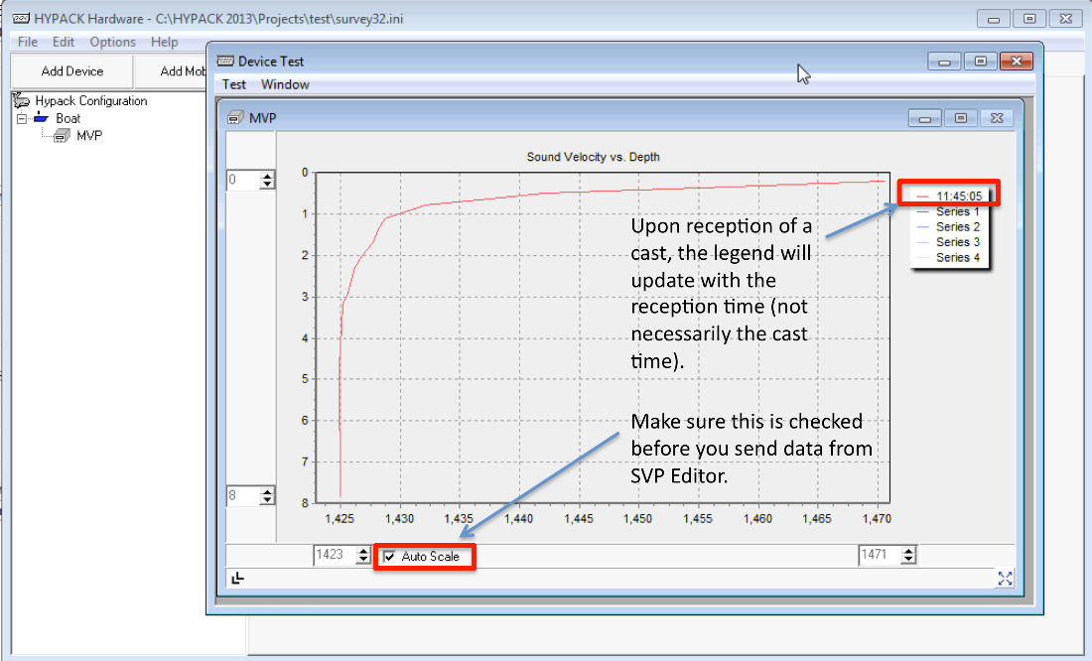

Figure 17 – Testing reception capabilities in Hypack. After having loaded a sample cast into SSP and send it, the profile should be visualized in Hypack (after clicking “Test” button).

### QINSy

QINSy accepts the same SVP transmission protocol as SIS, but a method to verify reception of the cast is not currently known thus the user should confirm reception in the acquisition system.

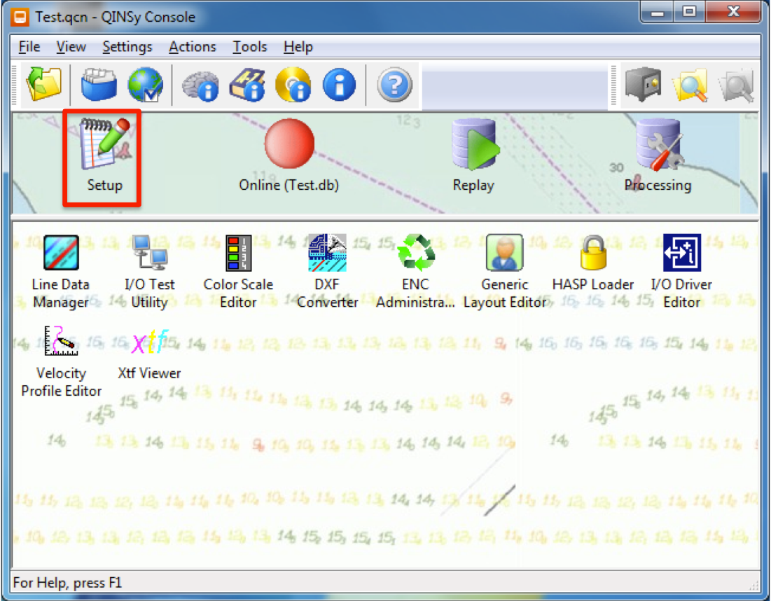

Figure 18 – Select ‘Setup’ from the QINSy console after loading your project. Refer to QINSy documentation for information regarding setting up a project.

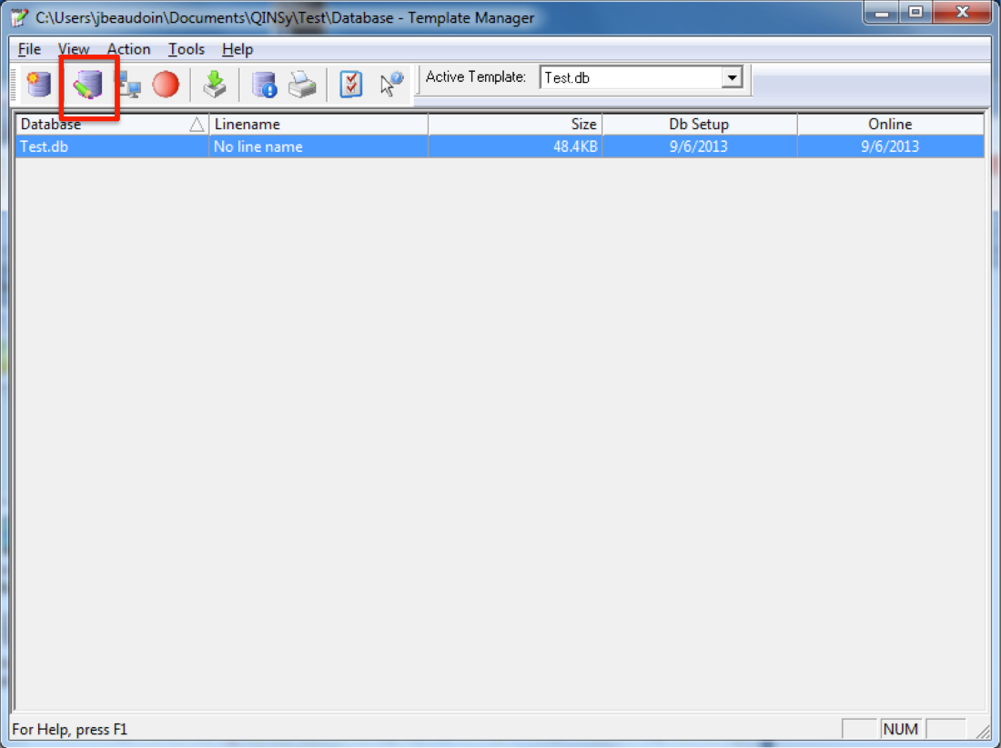

Figure 19 – Edit your project database

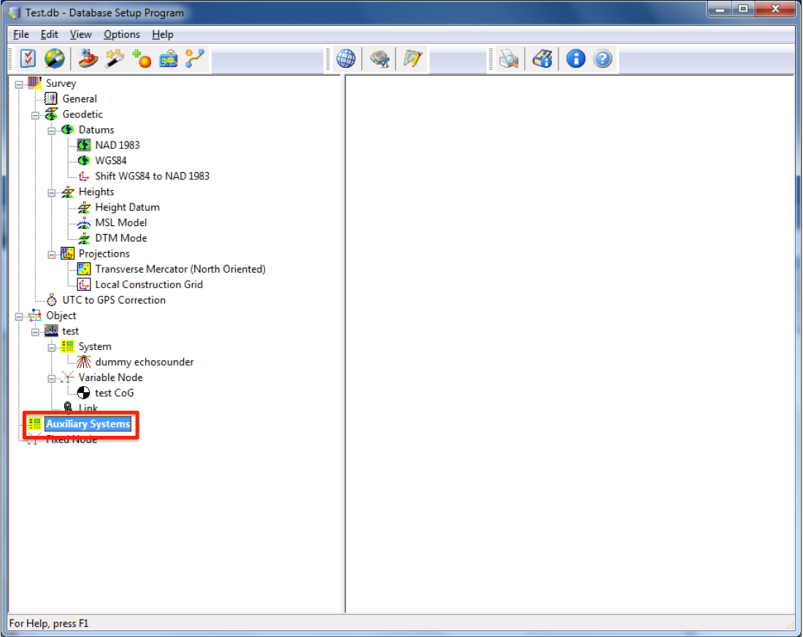

Figure 20 – Right click the ‘Auxiliary Systems’ icon and select ‘New System’.

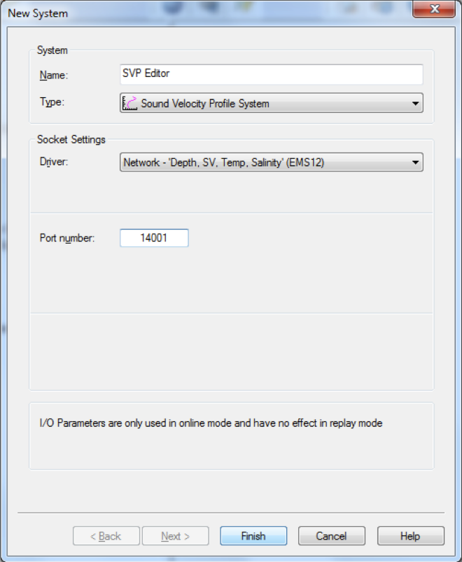

Figure 21 – Configure the new system as shown above. Choose the same port number that SSP package will be sending casts to (this is configured in the *config.ini* file).

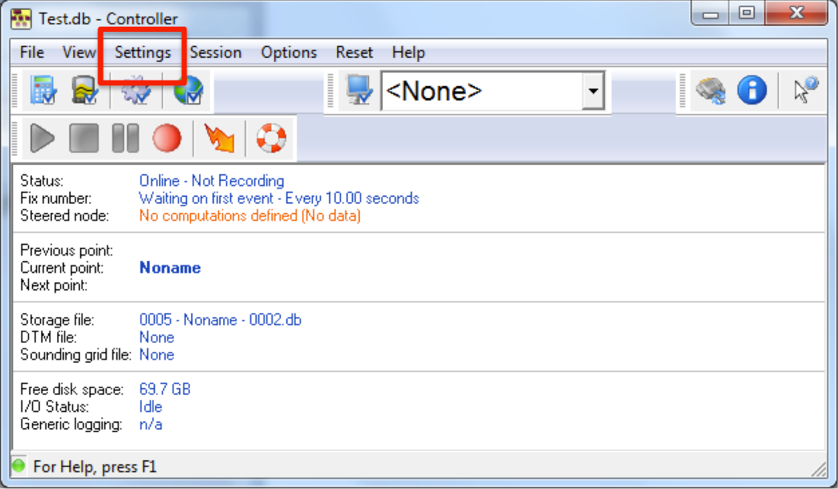

Figure 22 – Choose “Echosounder Settings” from the Settings menu. This will allow you to configure the behavior of QINSy when it receives new sound speed profiles from SSP package.

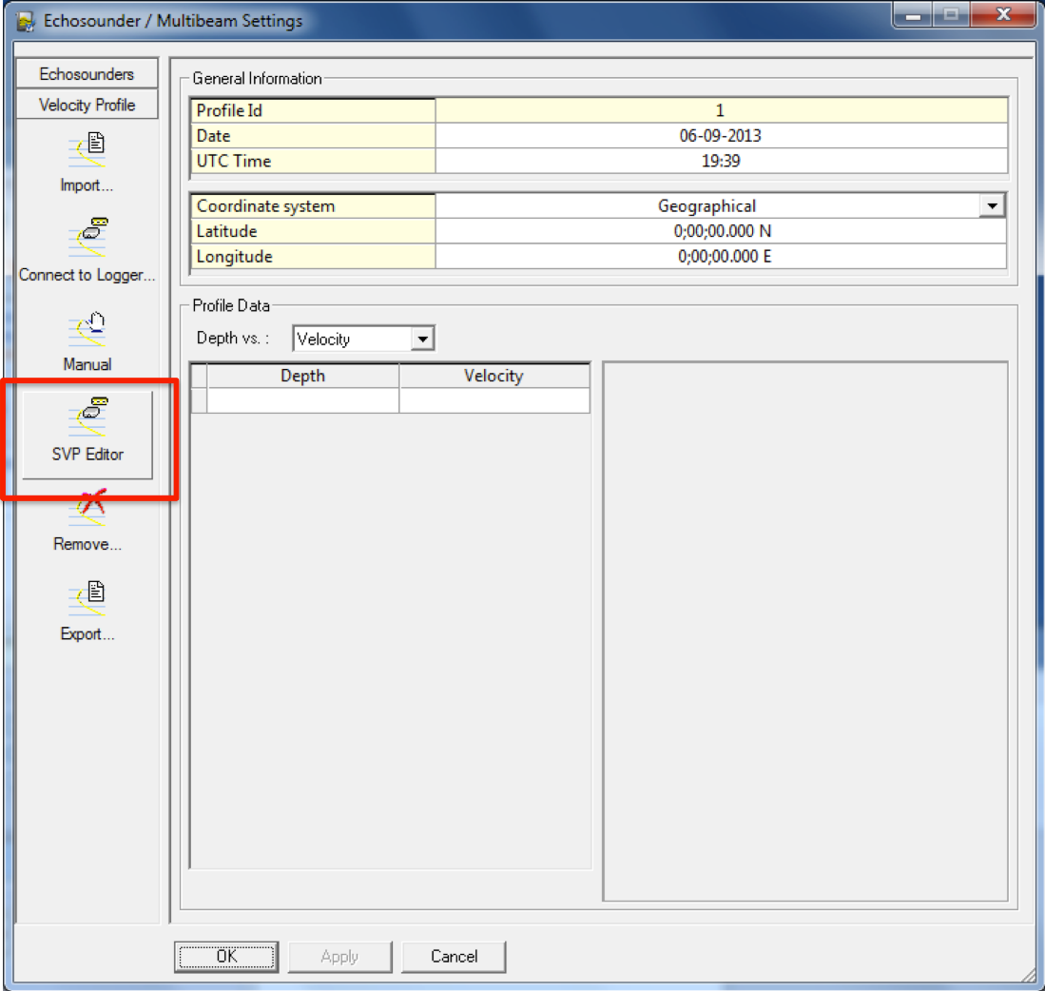

Figure 23 – Left­click the icon for the “SVP Editor” device.

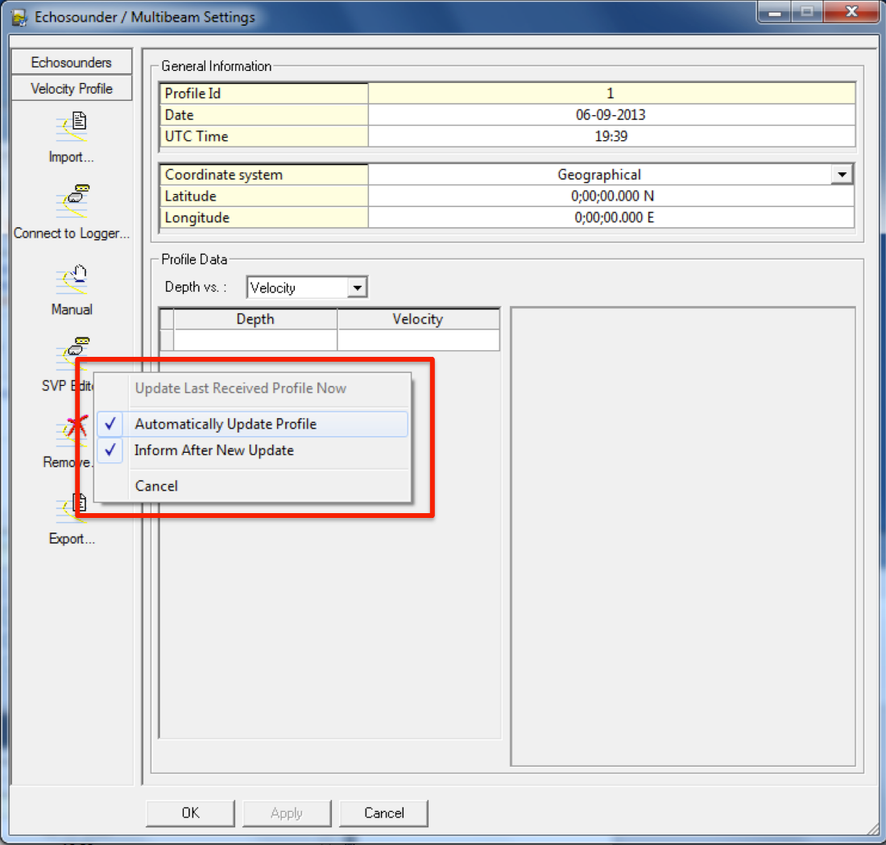

Figure 24 – Choose appropriate options to control QINSy’s behavior when it receives casts from SSP package. For initial testing purposes, you should at least choose to be informed after a new update.

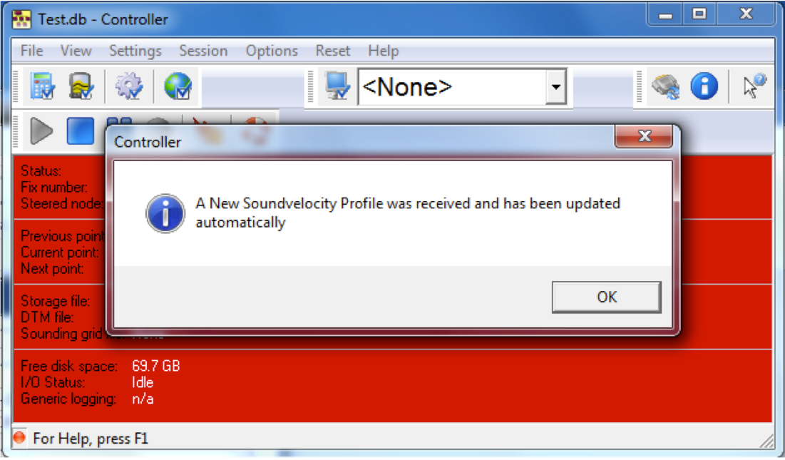

Figure 25 – With QINSy “online” and recording, send a test profile from SSP package. If you have chosen to be informed upon reception of a new cast, a message window will appear for acknowledgement.

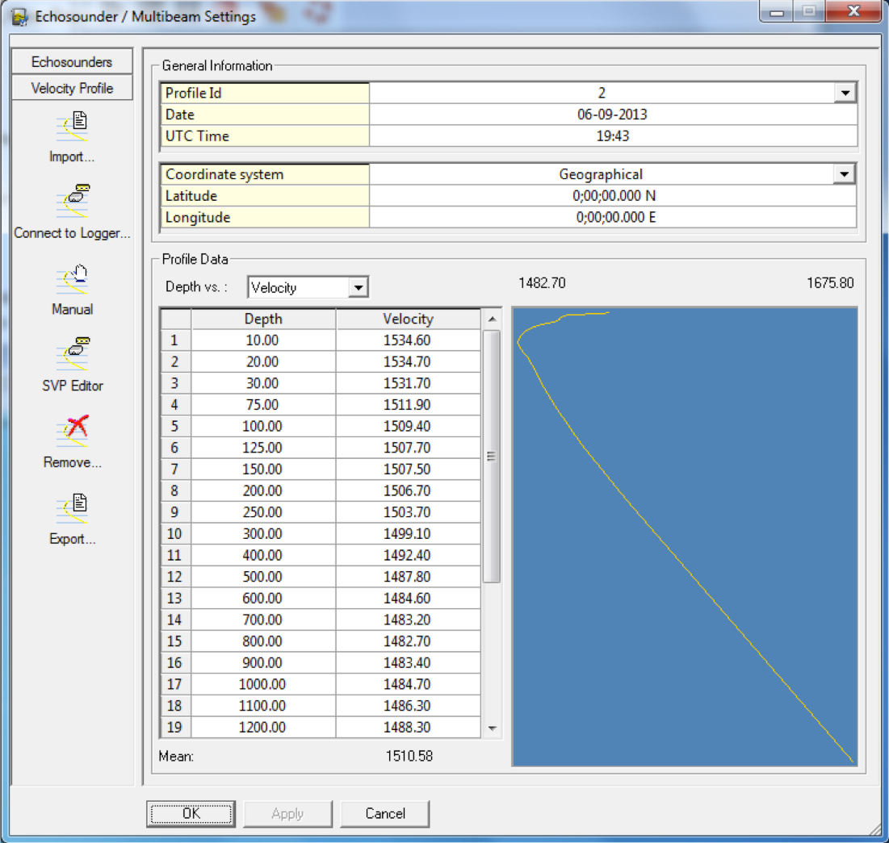

Figure 26 – By choosing “Echosounder Settings” from the “Settings” menu again, you can verify that the cast was received.

### PDS2000

PDS2000 accepts the same SVP transmission protocol as SIS, but a method to verify reception of the cast is not currently known thus the user must confirm reception in the acquisition system.

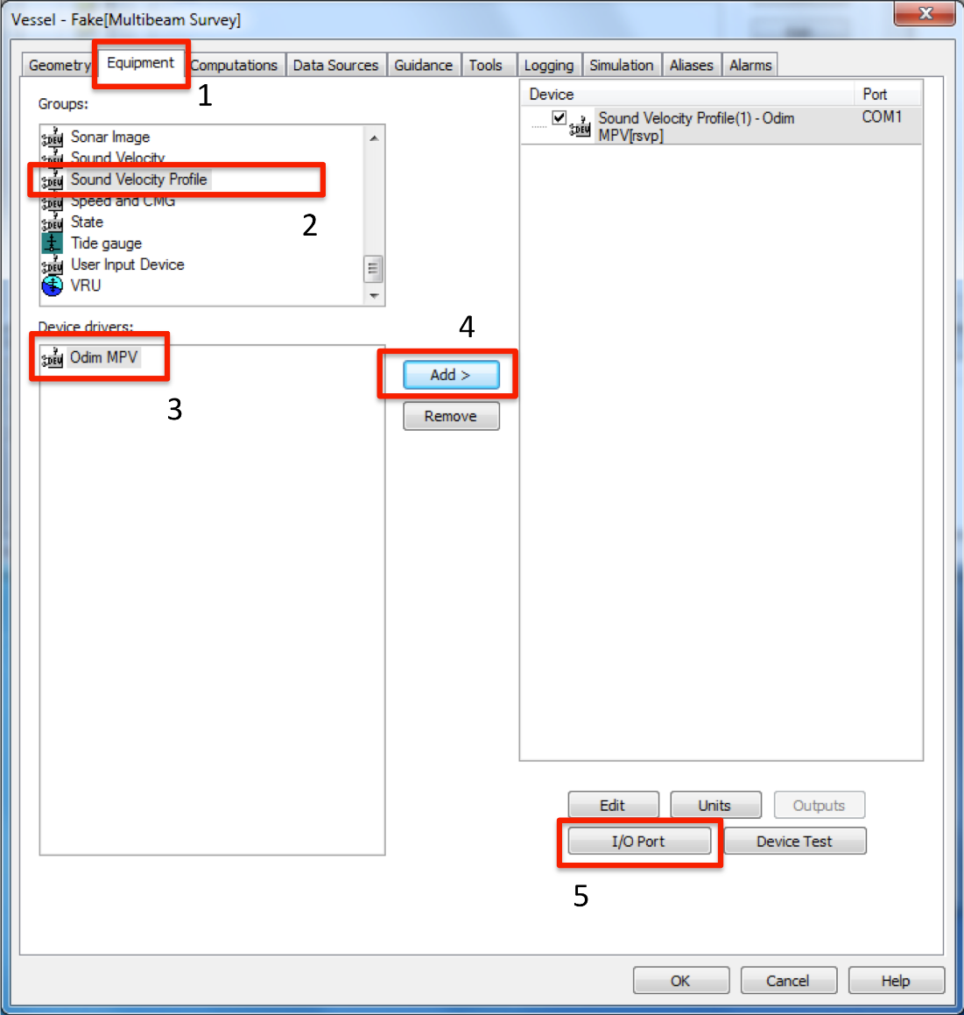

Figure 27 – Adding an MVP driver to PDS2000.

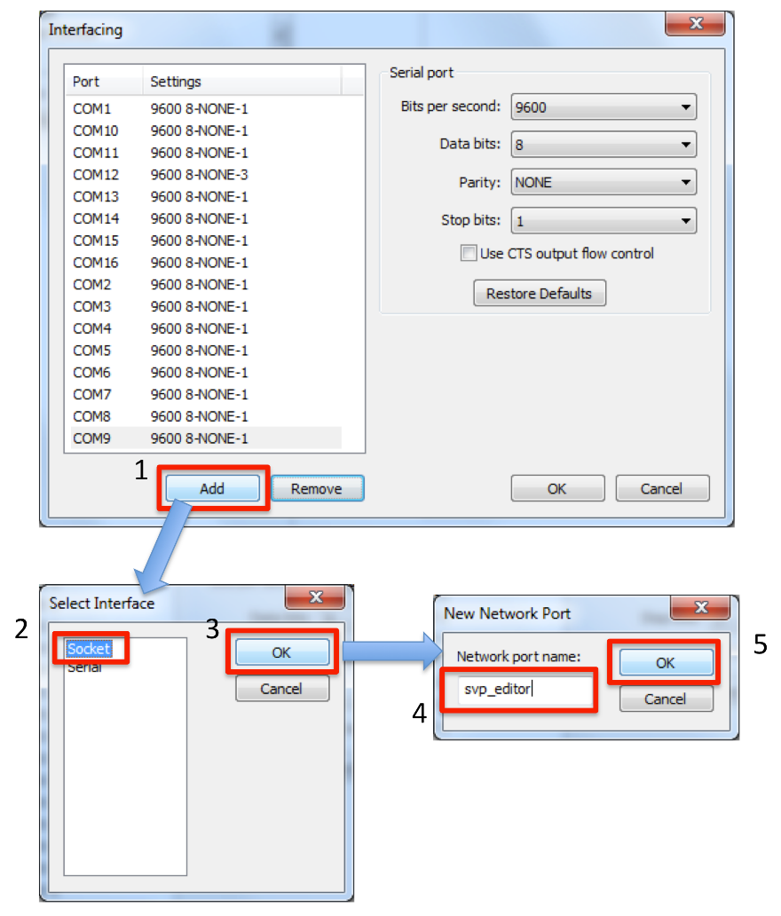

Figure 28 – Configuring the MVP driver for PDS2000.

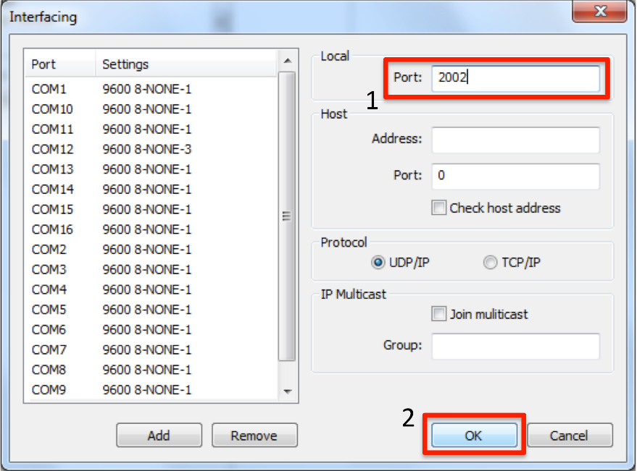

Figure 29 – Configuring an MVP driver for PDS2000. Be sure to scroll down in the list on the left side and choose the driver you added in the previous step before modifying the port number. The port number must match that which SSP package is sending data to (configured in the *config.ini* file).

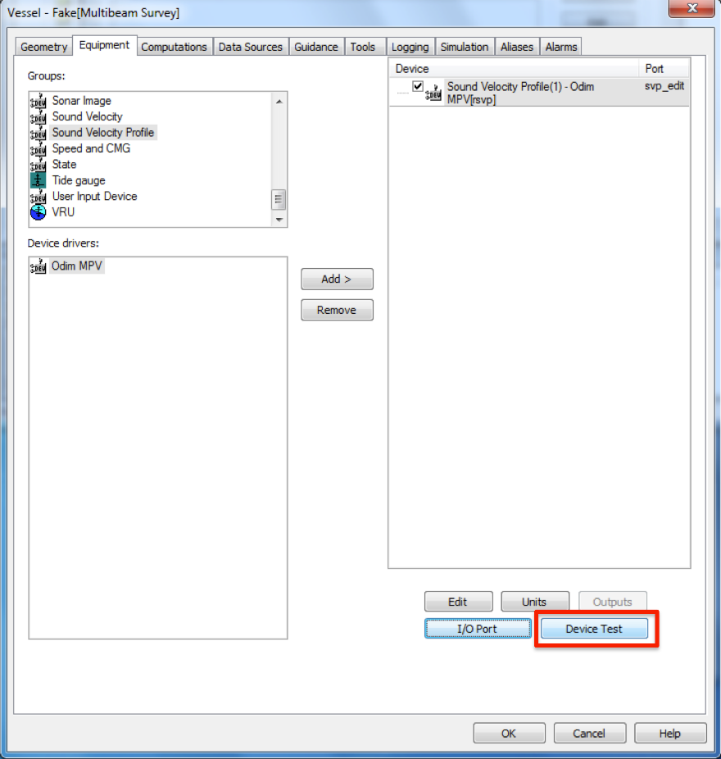

Figure 30 – After the driver is added, test the device to verify correct configuration of communication protocols.

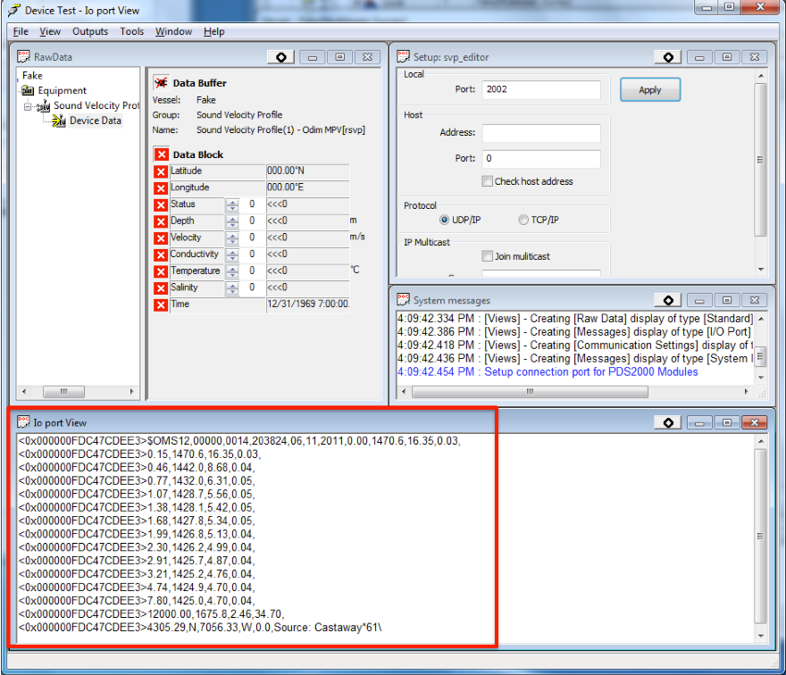

Figure 31 – With the device driver open, send a test cast from SSP package. The data should appear in the Io port View window. Be sure that the correct device driver is selected from the top left list window.

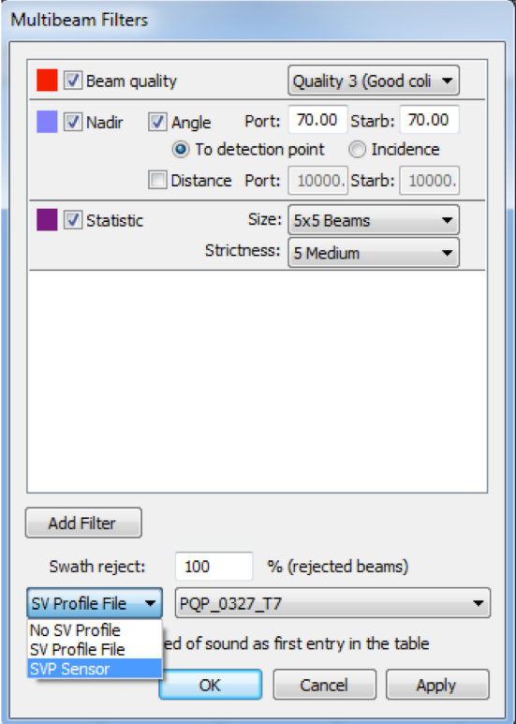

Figure 32 – While running PDS2000 in acquisition mode, right click in the multibeam raw profile display and choose “Multibeam filters”. Choose “SVP Sensor” as the source of sound speed profiles to be used.

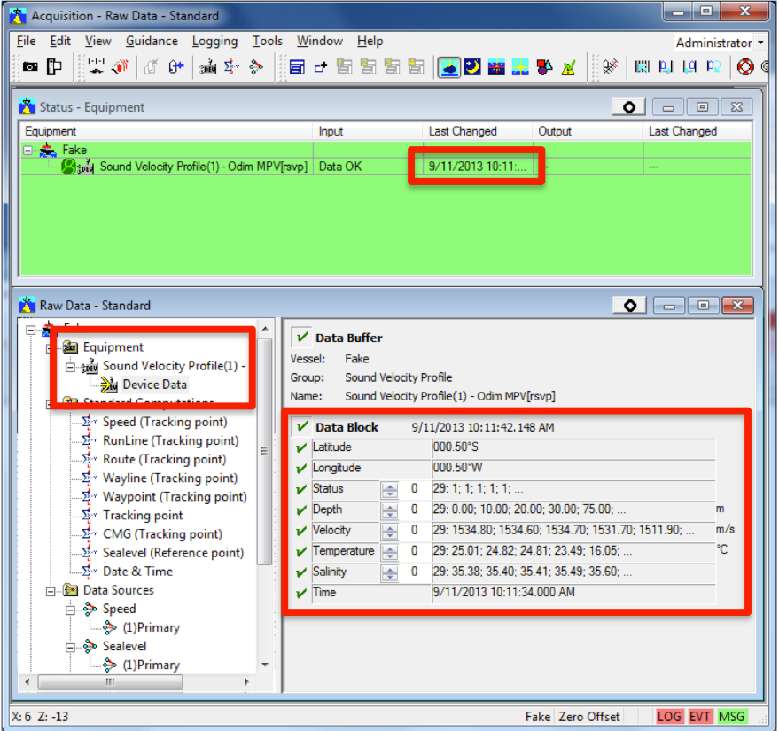

Figure 33 – While running PDS2000 in acquisition mode, you can verify reception in the Status displays and the “Raw Data” displays. Check the date, time, latitude, longitude against what you sent from SSP package.